***The Harbor Ridge Homeowner***

**A Publication of the Harbor Ridge Homeowners Association WINTER 2014**

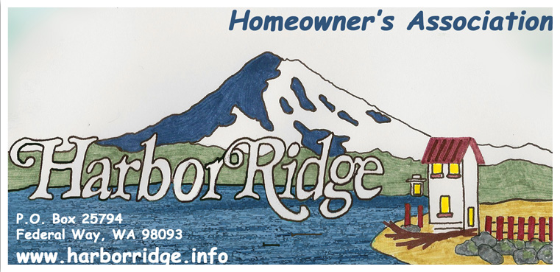

**The 2014 Annual Meeting will be**

**Sunday, January 19, 2014 at 3 p.m.**

**At Resurrection Lutheran Church**

**4301 Brown’s Pt. Blvd.**

**All Harbor Ridge homeowners are invited to participate.**

**This Newsletter serves as the announcement for the meeting.**

**AGENDA:**

* **INTRODUCTIONS**
* **RE-CAP OF 2013**
* **PLANS FOR 2014**
* **ELECTION OF BOARD MEMBERS**
* **SOCIAL TIME**

**THANK YOU** – to all of you who have made the effort to keep your homes and yards in such excellent condition and abiding by our covenants. This is particularly appreciated in view of the challenging financial period we are experiencing as a nation.

**ELECTION OF BOARD MEMBERS**

We are looking for neighbors to serve on the Harbor Ridge Homeowners Association Board. We currently have two openings and the term is for three years. We meet approximately nine times a year for 1 to 1 ½ hours. We would love to have your input. Please consider participating in your neighborhood development.

**DUES FOR 2014** – Please bring your $35 annual dues payment to the annual meeting, or mail to:

**Harbor Ridge Homeowners Association**

**P.O. Box 25794**

**Federal Way WA 98093 – 2794**

**ACCESS TO VALUABLE INFORMATION:**

**For detailed information on Fighting Crime at Home**:

www.cityoftacoma.org/cro/FightCrimeathomebrochure.pdf

**For City of Tacoma Resource guide:**

www.cityoftacoma.org/NeighborhoodCouncils/NCResourceGuideWEB.pdf

**For Safe and Clean Brochure:**

www.cityoftacoma.org/cityclerk/files/safeandclean/currentbrochure/5.2010.pdf

**For the NE Tacoma monthly publication, the NET News:**

* receive it in your e-mail by sending a note to [netnews98422@hotmail.com](mailto:netnews98422@hotmail.com), with ‘subscribe’ in the subject line, or
* regularly pick up a paper copy at any of these locations: Center at Norpoint, Kobetich Library, the Howards Corner and the Crescent Heights grocery stores, the TPD substation, North Shore Thai and the North Shore Cleaners (near Walgreens), the Cleaners by the QFC, and at Browns Point (the Diner, the Cleaners, and ACE hardware)

2013 has been challenging! Everything from bent or uprooted flag poles, and flattened fences during wind storms, to flooded crawl spaces during early Fall monsoons, to ruptured water pipes during our late Fall freeze, have kept our property owners hopping! These small disasters pale when compared to one of our neighbors losing their possessions and house in a major fire . . .

We are reminded of our somewhat fragile existence each time we hear the wail of an approaching fire engine, ambulance or police cruiser or pass the aftermath of a disaster that fell upon one of our neighbors. Several things each of us can do to keep our neighborhood and neighbors safe fall into the realm of ***“common sense”.***

Whenyou notice your neighbor left his garage door open after dark call and let him know.

If it is late and you notice those UPS packages on your neighbor’s doorstep give them a call. If no one is home, take the packages in or hide them. Our local news is full of stories about thieves following the UPS trucks and taking unattended packages! Let’s make sure our community guards against that crime.